Understanding Business Ethics

Business Ethics

Md Nahid Hasan

Matriculation No: 00803885

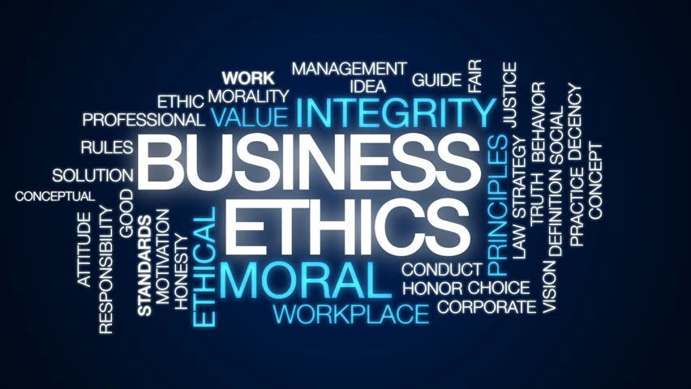

# Definition Of Business Ethics

Business ethics is the look at of suitable commercial enterprise guidelines and practices concerning probably debatable topics which include company governance, insider trading, bribery, discrimination, company social responsibility, and fiduciary responsibilities. The regulation frequently courses commercial enterprise ethics, however at different instances commercial enterprise ethics offer a fundamental guiding principle that companies can select to comply with to benefit public approval.

But good business ethics assures customers, employees and other stakeholders that a company is following the rules and doing the right thing. If other businesses don't trust you, they may buy the product elsewhere or offer bargains to other buyers. Business ethics is essential for good financial planning and positive income.

## Understanding Business Ethics

Consumers admire openness, because it presents them with perception into how a enterprise operates and conceptualizes the paintings that they do. Showing respect to employees and customers means keeping all promises and offering sincere apologies and proper compensation if something goes wrong. Treating customers and employees with fairness and equity is an important type of ethics. There are humans that devour items or offerings from the commercial enterprise, after which there are humans that paintings to provide the ones items or offerings. While understanding the fundamentals of business ethics is important, it is arguably more important to understand how these ideas apply to day-to-day business. Here are some examples of how ethical behavior can be applied in practice. For example, if a customer walks into a store looking for a product that meets very specific needs, it is important to offer them the best product for the situation described rather than selling it or promoting it. However, it is important to ensure that a “customer first” attitude does not inadvertently lead to unethical treatment of employees, such as encouraging them to work more overtime than is allowed. For example, when faced with a public relations crisis, companies should call a meeting and address the issue directly with their employees. For example, if someone notices that management tends to hire the same type of people, they might suggest that employees be more involved in the hiring process. One of the priorities of any business is to secure and protect this information. For example, a research university should have a neutral compliance office that is organizationally separate from its research department. Just as it is important to understand how to practice ethical behavior, it is equally important to understand what unethical behavior is. Here are some examples of unethical situations in the workplace. When a manager favors a favorite or senior employee or offers a mutually beneficial solution, he is engaging in unethical behavior. They need to allow both employees to have a say, and then find the solution that works best for both parties, as well as the company itself. Lying to your employees or customers is the best way to break trust. Trust is the best source of dedication and loyalty any business has. It is unethical to abuse company time because employees receive compensation for work, they do not complete or time they do not devote to their work. While there are certain conflicts in the workplace, it is important to make the workplace a safe environment for everyone.

## Importance of Business Ethics

Business ethics is important because it has lasting implications on many levels. With increasing investor awareness about environmental, social and governance issues, a company's reputation is at stake. For example, if a company engages in unethical practices, such as poor customer privacy practices and procedures, it could lead to a data breach. As a result, this can lead to significant customer loss, erosion of trust, less competitive hiring, and a drop in stock prices. However, demonstrating good ethical behavior is also essential to maintaining a positive reputation, both with the public and with employees. When an organization enjoys a good reputation in the marketplace, attracts and retains a strong customer base, and maintains a talented workforce, it often receives rewards in the form of revenue. Studies have shown that about half of the public pay attention to corporate social behavior, and 20% will actively report or refuse to do business with companies they believe are behaving inappropriately. morality. Customer loyalty is important to any business and losing customers can be quite costly. Additionally, a negative reputation can affect your chances of winning new customers. To attract and retain talent, companies must maintain an atmosphere of fairness and openness. Employees prefer to work in a positive environment where they can make progress based on merit rather than bias or other means. When workers sense injustice around them, their dedication to the organization suffers.